Paper’s title should be the fewest possible words that accurately describe the content of the paper (Center, Bold, 16pt)

Author¹, Author², Author³* (Center, Bold, 12pt)
¹Department of Management Information, University of Greenwich, United Kingdom; e-mail (10 pt)
²Department of Human Resources, Chinese Culture University, Taiwan; e-mail (10 pt)
³*Department of Organizational Behaviour, The University of Newcastle, Australia; e-mail (10 pt)
*Corresponding Author: e-mail
DOI:
Received: May XX, 2024 Revised: July XX, 2024 Accepted: July XX, 2024
ABSTRACT (Center, Bold, 14 pt)
An abstract is often presented separate from the article, so it must be able to stand alone. A well-prepared abstract enables the reader to identify the basic content of a document quickly and accurately, to determine its relevance to their interests, and thus to decide whether to read the document in its entirety. The abstract should be informative and completely self-explanatory, provide a clear statement of the problem, the proposed approach or solution, and point out major findings and conclusions. The Abstract should be 100 to 200 words in length. References should be avoided, but if essential, then cite the author(s) and year(s). Standard nomenclature should be used, and non-standard or uncommon abbreviations should be avoided, but if essential they must be defined at their first mention in the abstract itself. No literature should be cited. The keyword list provides the opportunity to add 5 to 7 keywords, used by the indexing and abstracting services, in addition to those already present in the title (12 pt).

Keywords: First keyword, Second keyword, Third keyword, Fourth keyword, Fifth keyword

1. Introduction (14 pt)
The main text format consists of a flat left-right columns on A4 paper (quarto). The margin text from the left and right are 2.0 cm, top and bottom are 2.2 cm. The manuscript is written in Microsoft Word, single space, Time New Roman 12 pt, and maximum 15 pages for original research article, or maximum 20 pages for review/survey paper, which can be downloaded at the website: http://itip.tw.com (12 pt).
A title of article should be the fewest possible words that accurately describe the content of the paper. The title should be succinct and informative and no more than about 12 words in length. Do not use acronyms or abbreviations in your title and do not mention the method you used, unless your paper reports on the development of a new method. Titles are often used in information-retrieval systems. Avoid writing long formulas with subscripts in the title. Omit all waste words such as "A study of ...", "Investigations of ...", "Implementation of ...”, "Observations on ...", "Effect of.....", “Analysis of …”, “Design of…”, etc.
A concise and factual abstract is required. The abstract should briefly state the purpose of the research, the principal results and major conclusions. An abstract is often presented separately from the article, so it must be able to stand alone. For this reason, References should be avoided, but if essential, then cite the author(s) and year(s). Also, non-standard or uncommon abbreviations should be avoided, but if essential they must be defined at their first mention in the abstract itself. Immediately after the abstract, provide a maximum of 7 keywords, using American spelling and avoiding general and plural terms and multiple concepts (avoid, for example, 'and', 'of'). Be sparing with abbreviations: only abbreviations firmly established in the field may be eligible. These keywords will be used for indexing purposes.
Indexing and abstracting services depend on the accuracy of the title, extracting from it keywords useful in cross-referencing and computer searching. An improperly titled paper may never reach the audience for which it was intended, so be specific. The Introduction section should provide: i) a clear background, ii) a clear statement of the problem, iii) the relevant literature on the subject, iv) the proposed approach or solution, and v) the new value of research which it is innovation (within 3-6 paragraphs). It should be understandable to colleagues from a broad range of scientific disciplines. Organization and citation of the bibliography are made in Institute of Electrical and Electronics Engineers (IEEE) style in sign [1], [2] and so on. The terms in foreign languages are written italic (italic). The text should be divided into sections, each with a separate heading and numbered consecutively [3]. The section or subsection headings should be typed on a separate line, e.g., 1. INTRODUCTION. A full article usually follows a standard structure: 1. Introduction, 2. The Comprehensive Theoretical Basis and/or the Proposed Method/Algorithm (Optional), 3. Method, 4. Results and Discussion, and 5. Conclusion. The structure is well-known as APA-7 style.
Literature review that has been done author used in the section "INTRODUCTION" to explain the motivation and background of the research or topic. Then, the section “LITERATURE REVIEW” should discussed the difference of the manuscript with other papers, that it is innovative. Further, it is used in the section "RESEARCH DESIGN" to describe the step of research and used in the section "RESULTS AND DISCUSSION" to support the analysis of the results [2]. If the manuscript was written really have high originality, which proposed a new method or algorithm, the additional section after the "INTRODUCTION" section and before the "RESEARCH DESIGN" section can be added to explain briefly the theory and/or the proposed method/algorithm [4].
2. Literature Review (14 pt)
2.1 The Emotional Labor (12 pt)
Emotional labor refers to the process of managing and regulating one's emotions to meet the emotional requirements of a job or social interaction [5]. It involves displaying specific emotions and suppressing others, often to create a desired emotional atmosphere or to fulfill the expectations of others. Emotional labor can be a significant component of various professions and interpersonal relationships.
Emotional labor involves adhering to "display rules," which are societal or workplace norms dictating which emotions are appropriate in a given context [6]. For example, a customer service representative may be expected to appear cheerful and patient. This practice involves altering one's outward emotional expressions while keeping inner emotions unchanged. It can be mentally and emotionally taxing but is commonly used in customer-facing roles. In contrast to surface acting, deep acting involves making an effort to genuinely feel the desired emotion [7,8]. It is often considered a healthier approach to emotional labor, as it reduces the emotional dissonance experienced by the individual. Service industry workers, such as flight attendants and waitstaff, often engage in emotional labor to create a positive customer experience. Healthcare professionals may need to manage their emotions when dealing with patients who are anxious, upset, or in pain [9,10,11]. Teachers must regulate their emotions to maintain a positive and supportive classroom environment.
Emotional labor can have both personal and societal implications. When done excessively or inauthentically, it may lead to emotional exhaustion and burnout. Recognizing and addressing emotional labor is essential for promoting emotional well-being in the workplace and personal relationships.
2.2 The Social Skills (12 pt)
Social skills are a set of interpersonal and communication abilities that allow individuals to interact effectively with others in various social and professional situations [12]. These skills are essential for building and maintaining relationships, resolving conflicts, and navigating social environments successfully. Effective communication is a cornerstone of social skills. It includes active listening, clear expression of ideas, and non-verbal communication like body language. Empathy is the ability to understand and share the feelings of others [13,14]. It helps in building strong connections and responding to others' emotions. Social skills involve the capacity to manage conflicts peacefully and find mutually agreeable solutions. Being assertive, but not aggressive, is an important aspect of social skills [15]. It involves expressing one's needs and boundaries while respecting the rights of others.
How to improve social skills? Improving social skills can lead to more fulfilling relationships and greater success in both personal and professional life [16]. Strategies for improvement include developing emotional intelligence can enhance social skills by increasing self-awareness and understanding of others' emotions [17]. Engaging in social interactions and practicing communication in various contexts can enhance social skills. Asking for feedback from trusted individuals can provide insights into areas for improvement. Some individuals may benefit from formal training or therapy to develop social skills. Social skills play a crucial role in creating a positive social environment, fostering cooperation, and building meaningful connections. They are essential for personal growth and success in various aspects of life.
3. Research Design(14 pt)
Explaining research chronological, including research design, research procedure (in the form of algorithms, Pseudocode or other), how to test and data acquisition [5,6,7]. The description of the course of research should be supported references, so the explanation can be accepted scientifically [2,4]. Figures 1-2 and Table 1 are presented center, as shown below and cited in the manuscript [5], [8,9,13]. The variation of average repeater spacing RR, km against number of links as shown in Figure 1(a) and initial Raman pump wavelength shown in Figure 1(b).

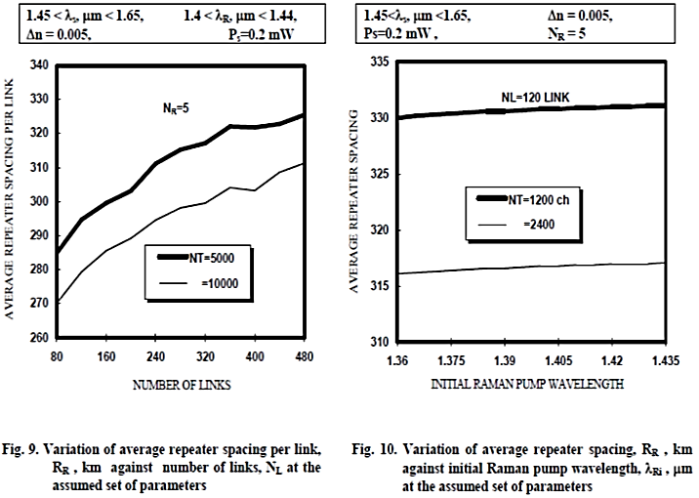 | 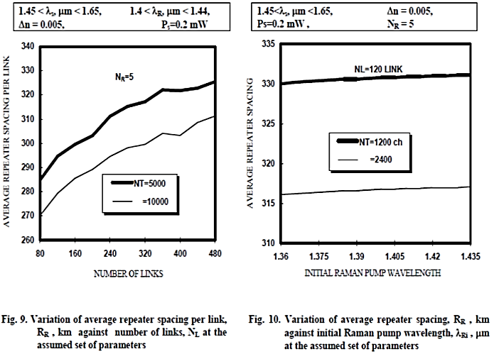
Figure 1. Variation of average repeater spacing RR, km against (a) number of links and
(b) initial Raman pump wavelength
Source: By authors.

Table 1. The performance of …
Variable | Speed (rpm) | Power (kW)
x | 10 | 8.6
y | 15 | 12.4
z | 20 | 15.3
Source: By authors.

4. Results and Discussion (14 pt)
In this section, it is explained the results of research and at the same time is given the comprehensive discussion. Results can be presented in figures, graphs, tables and others that make the reader understand easily [14], [15]. The discussion can be made in several sub-sections.
4.1 Sub Section 1 (12 pt)
Equations should be placed at the center of the line and provided consecutively with equation numbers in parentheses flushed to the right margin, as in (1). The use of Microsoft Equation Editor or MathType is preferred.
$E_{v}-E=\frac{h}{2.m} (k_{x}^{2}+k_{y}^{2})$ [Formular 1]
Ev:
E:
h:
m:
k:
All symbols that have been used in the equations should be defined in the following text.
4.2 Sub Section 2 (12 pt)
Proper citation of other works should be made to avoid plagiarism. When referring to a reference item, please use the reference number as in [16] or [17] for multiple references. The use of ”Ref [18]...” should be employed for any reference citation at the beginning of sentence. For any reference with more than 3 or more authors, only the first author is to be written followed by et al. (e.g. in [19]). Examples of reference items of different categories shown in the References section. Each item in the references section should be typed using 8 pt font size [20,21].
4.2.1. Subsub section 1 (12 pt)
Some descriptions writs down here.
4.2.2. Subsub section 2 (12 pt)
Some descriptions writs down here.
5. Conclusions (14 pt)
Provide a statement that what is expected, as stated in the "INTRODUCTION" section can ultimately result in "RESULTS AND DISCUSSION" section, so there is compatibility. Moreover, it can also be added the prospect of the development of research results and application prospects of further studies into the next (based on result and discussion).
Acknowledgements (14 pt)
Author thanks .... In most cases, sponsor and financial support acknowledgments.
References (12 pt)
The main references are international journals and proceedings. All references should be to the most pertinent, up-to-date sources and the minimum of references are 25 entries (for original research paper) and 50 entries (for review/survey paper). Please use a consistent format for references-see examples (10 pt):

Journal (10 pt)
[1] Wu, C.H., Yuan, Y.C. and Tsai, S.B. Using the DEMATEL model to expose core causal items of LibQUAL for improving library service quality: from the perspective of big data. Soft Computing, 2020, 24, 5729-5739. DOI: 10.1007/s00500-019-04308-5.
[2] Guo, J., Zhang, H., Lin, W., Lu, L., Su, J. and Chen, X. Signaling pathways and targeted therapies for psoriasis. Signal Transduction and Targeted Therapy, 2023, 8(1), 437. DOI:10.1038/s41392-022-00925-z.
Conference (10 pt)
[3] Mostafa, S., Mubarak, R., El-Adawy, M., Ibrahim, A.F., Gomaa, M.M. and Kamal, R.M. Breast Cancer Detection Using Polynomial Fitting Applied on Contrast Enhanced Spectral Mammography. 2019 International Conference on Innovative Trends in Computer Engineering, 2019, 11-26. DOI: 10.1109/ITCE.2019.8646379.

Book (10 pt)
[4] Chakraborty, A. and Kar, A. K. ”Swarm Intelligence: A Review of Algorithms”. Nature-Inspired Computing and Optimization Modeling and Optimization, Switzerland: Springer, 2017.

Thesis/Dissertation (10 pt)
[5] Mäckel H. Capturing the Spectra of Silicon Solar Cells [PhD thesis]. The Australian National University, 2004.

Online resources (10 pt)
[6] Author (if available). Title of content (if available). Available online: http://URL
Weier M.H. In a big win for HP, Wal‐Mart chooses Neoview Data Warehouse. Available online: http://www.informationweek.com/news/201202317.

